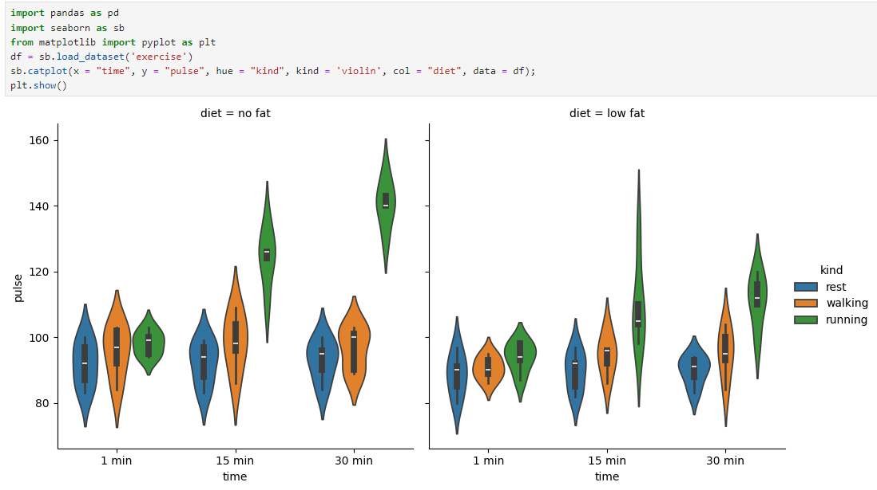

**What is a Catplot or Categorical plot?**

Catplot in Seaborn is a versatile function that allows you to create different types of plots that display relationships between a categorical variable and one or more numerical variables. It can create plots like bar plots, violin plots, box plots, etc., depending on the kind parameter. In this case, the plot type specified is a "violin" plot, which shows the distribution of data across different categories.

**Interpretation of the Provided Catplot:**

1. **Axes**:
   * **x-axis (time)**: Represents the duration of exercise, with three time intervals: 1 minute, 15 minutes, and 30 minutes.
   * **y-axis (pulse)**: Represents the pulse rate of individuals after exercise.
2. **Columns (diet)**:
   * The plot is divided into two panels based on the diet variable, showing data for "no fat" and "low fat" diets.
3. **Colors (kind)**:
   * The plot uses different colors to represent different types of exercises: blue for "rest," orange for "walking," and green for "running."
4. **Violin Plot**:
   * Each "violin" shape represents the distribution of pulse rates for a particular combination of time, kind, and diet.
   * The width of each violin represents the density of data points at different pulse rates. The black bar inside each violin shows the interquartile range (IQR), and the white dot represents the median pulse rate.

**Key Observations:**

1. **Diet and Pulse Rate**:
   * Both "no fat" and "low fat" diets show similar trends in pulse rate across different exercise types and durations.
2. **Effect of Exercise Duration**:
   * As the exercise duration increases from 1 minute to 30 minutes, pulse rates generally increase, especially for more intense exercises like running.
   * For "rest," pulse rates remain fairly constant across all time intervals, showing narrow violins, indicating less variability.
3. **Exercise Type**:
   * **Running** (green violins) consistently shows higher pulse rates compared to walking and rest, especially at 15 and 30 minutes.
   * **Walking** (orange violins) results in moderate pulse rates, with a small increase as time increases.
   * **Rest** (blue violins) shows the lowest and most stable pulse rates across all time intervals.
4. **Diet Comparison**:
   * The general shape and distribution of pulse rates are similar between the "no fat" and "low fat" diet groups, suggesting that diet may not have a significant effect on pulse rate response to exercise in this dataset.

**Conclusion:**

This catplot reveals how different exercises, performed over varying durations, affect pulse rates under different dietary conditions. Running consistently elevates pulse rates the most, while rest shows minimal change, regardless of diet. The overall distribution patterns of pulse rates are quite similar between "no fat" and "low fat" diets.